**AIM: DEMONSTRATE USAGE OF DATA BOUND CONTROLS, SIMPLE STORED PROCEDURE AND PARAMETERIZED STORED PROCEDURES IN ASP.NET**

**WebConfig:**

<add name="ApplicationServices" connectionString="server=. ; database=narender_p4; Trusted_Connection=Yes;" providerName="System.Data.SqlClient"/>

**DATABASE:**

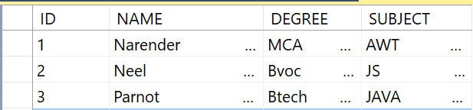

1. **Create a web page that demonstrates the use of data bound controls of ASP.NET.**

**SOURCE CODE:**

**DataBound.aspx:**

<%@ Page Language="C#" AutoEventWireup="true" CodeFile="DataBound.aspx.cs" Inherits="DataBound" %>

<!DOCTYPE html PUBLIC "-//W3C//DTD XHTML 1.0 Transitional//EN" "http://www.w3.org/TR/xhtml1/DTD/xhtml1-transitional.dtd">

<html xmlns="http://www.w3.org/1999/xhtml">

<head runat="server">

<title></title>

</head>

<body>

<form id="form1" runat="server">

<div>

<h2>Display Data using Connected Architecture</h2>

<asp:GridView ID="GridView1" runat="server" AutoGenerateColumns="False" CellPadding="6" OnRowCancelingEdit="GridView1_RowCancelingEdit" OnRowEditing="GridView1_RowEditing" OnRowUpdating="GridView1_RowUpdating">

<Columns>

<asp:TemplateField>

<ItemTemplate>

<asp:Button ID="btn_Edit" runat="server" Text="Edit" CommandName="Edit" />

</ItemTemplate>

<EditItemTemplate>

<asp:Button ID="btn_Update" runat="server" Text="Update" CommandName="Update"/>

<asp:Button ID="btn_Cancel" runat="server" Text="Cancel" CommandName="Cancel"/>

</EditItemTemplate>

</asp:TemplateField>

<asp:TemplateField HeaderText="ID">

<ItemTemplate>

<asp:Label ID="lbl_ID" runat="server" Text='<%#Eval("ID") %>'></asp:Label>

</ItemTemplate>

</asp:TemplateField>

<asp:TemplateField HeaderText="NAME">

<ItemTemplate>

<asp:Label ID="lbl_Name" runat="server" Text='<%#Eval("NAME") %>'></asp:Label>

</ItemTemplate>

<EditItemTemplate>

<asp:TextBox ID="txt_Name" runat="server" Text='<%#Eval("NAME") %>'></asp:TextBox>

</EditItemTemplate>

</asp:TemplateField>

<asp:TemplateField HeaderText="COURSE">

<ItemTemplate>

<asp:Label ID="lbl_Course" runat="server" Text='<%#Eval("DEGREE") %>'></asp:Label>

</ItemTemplate>

<EditItemTemplate>

<asp:TextBox ID="txt_Course" runat="server" Text='<%#Eval("DEGREE") %>'></asp:TextBox>

</EditItemTemplate>

</asp:TemplateField>

<asp:TemplateField HeaderText="SUBJECT">

<ItemTemplate>

<asp:Label ID="lbl_Subject" runat="server" Text='<%#Eval("SUBJECT") %>'></asp:Label>

</ItemTemplate>

<EditItemTemplate>

<asp:TextBox ID="txt_Subject" runat="server" Text='<%#Eval("SUBJECT") %>'></asp:TextBox>

</EditItemTemplate>

</asp:TemplateField>

</Columns>

<HeaderStyle BackColor="#663300" ForeColor="#ffffff"/>

<RowStyle BackColor="#e7ceb6"/>

</asp:GridView>

</div>

</form>

</body>

</html>

**DataBound.aspx.cs:**

using System;

using System.Web.UI.WebControls;

using System.Data;

using System.Data.SqlClient;

using System.Configuration;

public partial class DataBound : System.Web.UI.Page

{

//Connection String from web.config File

string cs = ConfigurationManager.ConnectionStrings["ApplicationServices"].ConnectionString;

SqlConnection con;

SqlDataAdapter adapt;

DataTable dt;

protected void Page_Load(object sender, EventArgs e)

{

if(!IsPostBack)

{

ShowData();

}

}

//ShowData method for Displaying Data in Gridview

protected void ShowData()

{

dt = new DataTable();

con = new SqlConnection(cs);

con.Open();

adapt = new SqlDataAdapter("Select ID,NAME,DEGREE,SUBJECT from student",con);

adapt.Fill(dt);

if(dt.Rows.Count>0)

{

GridView1.DataSource = dt;

GridView1.DataBind();

}

con.Close();

}

protected void GridView1_RowEditing(object sender, System.Web.UI.WebControls.GridViewEditEventArgs e)

{

//NewEditIndex property used to determine the index of the row being edited.

GridView1.EditIndex = e.NewEditIndex;

ShowData();

}

protected void GridView1_RowUpdating(object sender, System.Web.UI.WebControls.GridViewUpdateEventArgs e)

{

//Finding the controls from Gridview for the row which is going to update

Label id=GridView1.Rows[e.RowIndex].FindControl("lbl_ID") as Label;

TextBox name = GridView1.Rows[e.RowIndex].FindControl("txt_NAME") as TextBox;

TextBox course = GridView1.Rows[e.RowIndex].FindControl("txt_COURSE") as TextBox;

TextBox subject = GridView1.Rows[e.RowIndex].FindControl("txt_SUBJECT") as TextBox;

con = new SqlConnection(cs);

con.Open();

//updating the record

SqlCommand cmd = new SqlCommand("Update student set NAME='"+name.Text+"',DEGREE='"+course.Text+"',SUBJECT='"+subject.Text+"' where ID="+Convert.ToInt32(id.Text),con);

cmd.ExecuteNonQuery();

con.Close();

//Setting the EditIndex property to -1 to cancel the Edit mode in Gridview

GridView1.EditIndex = -1;

//Call ShowData method for displaying updated data

ShowData();

}

protected void GridView1_RowCancelingEdit(object sender, System.Web.UI.WebControls.GridViewCancelEditEventArgs e)

{

//Setting the EditIndex property to -1 to cancel the Edit mode in Gridview

GridView1.EditIndex = -1;

ShowData();

}

}

**OUTPUT:**

BEFORE EDITING:

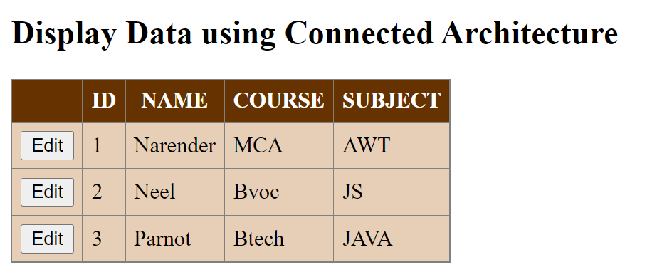

EDITING:

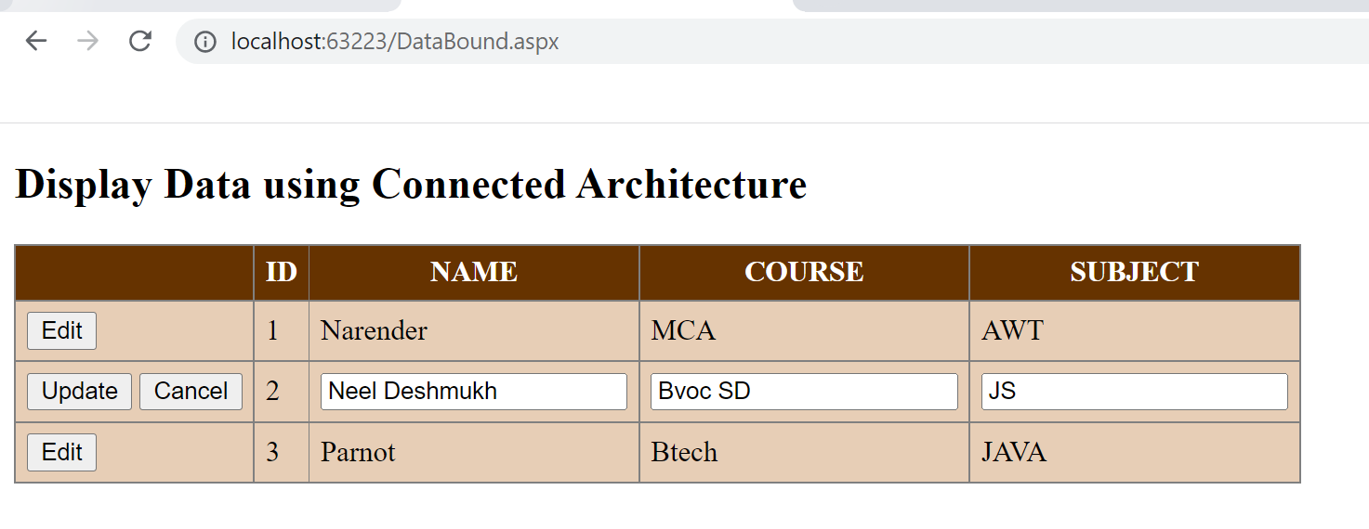

AFTER EDITING:

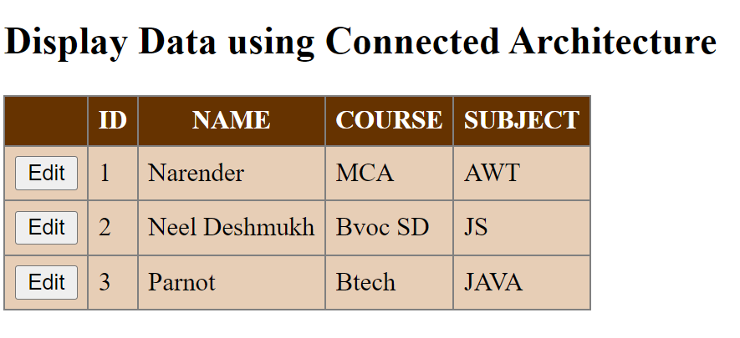

1. **Design a web page to demonstrate the working of a simple stored procedure.**

**DATABASE:**

CREATE OR ALTER PROCEDURE simpleStudentProcedureByNarender

AS

select * from narender_p4.dbo.student

GO;

**SOURCE CODE:**

**StoredProcedure.aspx:**

<%@ Page Language="C#" AutoEventWireup="true" CodeFile="StoredProcedure.aspx.cs" Inherits="StoredProcedure" %>

<!DOCTYPE html PUBLIC "-//W3C//DTD XHTML 1.0 Transitional//EN" "http://www.w3.org/TR/xhtml1/DTD/xhtml1-transitional.dtd">

<html xmlns="http://www.w3.org/1999/xhtml">

<head runat="server">

<title></title>

</head>

<body>

<form id="form1" runat="server">

<div>

<asp:GridView ID="GridView1" runat="server">

</asp:GridView>

</div>

</form>

</body>

</html>

**StoredProcedure.aspx.cs:**

using System;

using System.Collections.Generic;

using System.Linq;

using System.Web;

using System.Web.UI;

using System.Web.UI.WebControls;

using System.Data;

using System.Data.SqlClient;

using System.Configuration;

public partial class StoredProcedure : System.Web.UI.Page

{

string cs = ConfigurationManager.ConnectionStrings["ApplicationServices"].ConnectionString;

SqlConnection con;

protected void Page_Load(object sender, EventArgs e)

{

con = new SqlConnection(cs);

con.Open();

System.Data.SqlClient.SqlCommand objCmd = new System.Data.SqlClient.SqlCommand("simpleStudentProcedureByNarender", con);

objCmd.CommandType = System.Data.CommandType.StoredProcedure;

GridView1.DataSource = objCmd.ExecuteReader();

GridView1.DataBind();

con.Close();

}

}

**OUTPUT:**

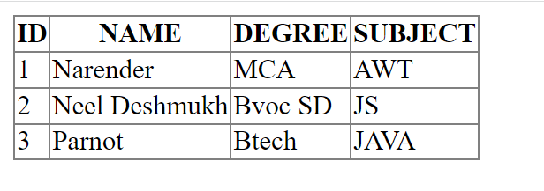

1. **Design a web page to demonstrate the working of parameterized stored procedure.**

**DATABASE:**

CREATE OR ALTER PROCEDURE paramStudentProcedureByNarender(

@ID INT, @NAME NVARCHAR(50), @DEGREE NVARCHAR(50), @SUBJECT NVARCHAR(50) )

AS

BEGIN

INSERT INTO student( [ID], [NAME], [DEGREE], [SUBJECT] )

VALUES ( @ID, @NAME, @DEGREE, @SUBJECT )

END

**SOURCE CODE:**

**ParameterSP.aspx:**

<%@ Page Language="C#" AutoEventWireup="true" CodeFile="ParameterSP.aspx.cs" Inherits="ParameterSP" %>

<!DOCTYPE html PUBLIC "-//W3C//DTD XHTML 1.0 Transitional//EN" "http://www.w3.org/TR/xhtml1/DTD/xhtml1-transitional.dtd">

<html xmlns="http://www.w3.org/1999/xhtml">

<head runat="server">

<title></title>

</head>

<body>

<form id="form1" runat="server">

<div>

<asp:Label ID="Label1" runat="server" Text="ID"></asp:Label>

<asp:TextBox ID="TextBox1" runat="server"></asp:TextBox><br /><br />

<asp:Label ID="Label2" runat="server" Text="NAME"></asp:Label>

<asp:TextBox ID="TextBox2" runat="server"></asp:TextBox><br /><br />

<asp:Label ID="Label3" runat="server" Text="DEGREE"></asp:Label>

<asp:TextBox ID="TextBox3" runat="server"></asp:TextBox><br /><br />

<asp:Label ID="Label4" runat="server" Text="SUBJECT"></asp:Label>

<asp:TextBox ID="TextBox4" runat="server"></asp:TextBox><br /><br /><br />

<asp:Button ID="Button1" runat="server" Text="Submit Record" OnClick="Button1_Click" />

<asp:Label ID="lblResult" runat="server" Text=""></asp:Label>

</div>

</form>

</body>

</html>

**ParameterSP.aspx.cs:**

using System;

using System.Collections.Generic;

using System.Linq;

using System.Web;

using System.Web.UI;

using System.Web.UI.WebControls;

using System.Data;

using System.Data.SqlClient;

using System.Configuration;

public partial class ParameterSP : System.Web.UI.Page

{

string cs = ConfigurationManager.ConnectionStrings["ApplicationServices"].ConnectionString;

SqlConnection con;

SqlCommand cmd = new SqlCommand();

SqlParameter sp1, sp2, sp3, sp4;

protected void Page_Load(object sender, EventArgs e)

{

}

protected void Button1_Click(object sender, EventArgs e)

{

con = new SqlConnection(cs);

cmd = new SqlCommand("paramStudentProcedureByNarender", con);

cmd.CommandType = CommandType.StoredProcedure;

sp1 = new SqlParameter("@ID", SqlDbType.Int);

sp2 = new SqlParameter("@NAME", SqlDbType.NVarChar);

sp3 = new SqlParameter("@DEGREE", SqlDbType.NVarChar);

sp4 = new SqlParameter("@SUBJECT", SqlDbType.NVarChar);

sp1.Value = Convert.ToInt32(TextBox1.Text);

sp2.Value = TextBox2.Text;

sp3.Value = TextBox3.Text;

sp4.Value = TextBox4.Text;

cmd.Parameters.Add(sp1);

cmd.Parameters.Add(sp2);

cmd.Parameters.Add(sp3);

cmd.Parameters.Add(sp4);

con.Open();

try

{

cmd.ExecuteNonQuery();

lblResult.Text = "Successfully inserted!";

}

catch (Exception)

{

lblResult.Text = "Error was occured!";

}

con.Close();

}

}

**OUTPUT:**

Before Inserting:

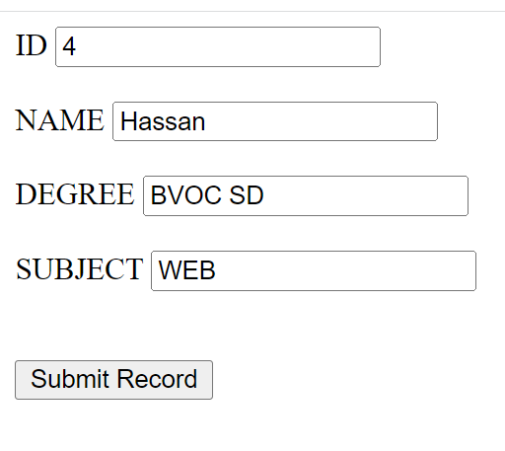

After Inserting:

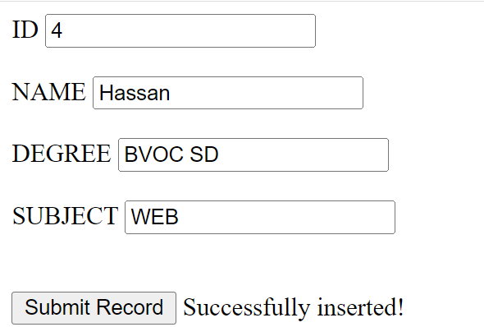

**CONCLUSION:**

From this practical, I have learned about data bound controls, simple stored procedure and parameterized stored procedures in ASP.NET.